JavaScript Assignment #4

**Part 1: Feeling Loopy**Start with A2P2 and check for bad input & re-prompt as needed using while loop

No screen shot needed.

[Paste your part 1 Code below – Make sure that ALL of your code is visible between the margins of this page]

<!doctype html>

<html>

<head>

<meta charset="utf-8">

<title>A4P1 by Frank Pedraza</title>

</head>

<body style="background-color: lightgrey">

<h1>A4P1 House of Cards Magic Shop</h1>

<p>Shop here and make your money disappear.</p>

<p>This months specials:</p>

<table border="1" cellspacing="0" cellpadding="6" summary="Table of product images and prices and descriptions">

<tbody>

<tr>

<td><img src="Images/magic_wand.png" alt="Magic Wand" height="150" width="150"></td>

<td><p style="font-weight: bold">$4 Magic Wand</p>

<p>Every magician needs a magic wand.</p></td>

</tr>

<tr>

<td><img src="Images/cards.png" alt="Playing Cards" height="150" width="150"></td>

<td><p style="font-weight: bold">$7 Set of Playing Cards</p>

<p>Perfect for party tricks, or for playing poker.</p></td>

</tr>

</tbody>

</table>

<script>

var FirstName = prompt('Welcome to House of Cards Magic Shop. Please enter your name.');

while(FirstName == “”){

FirstName = prompt('Invalid input.\nPlease enter your name.');

}

var numWand = prompt(FirstName+', How many magic wands would you like to purchase today?');

numWand=parseInt(numWand);

while(isNaN(numWand) || (numWand<0) || (numWand >100)){

numWand = prompt('Invalid input.\nPlease enter a valid number.');

numWand=parseInt(numWand);

}

var numCards = prompt(FirstName+', How many sets of playing cards would you like to purchase today?');

numCards=parseInt(numCards);

while(isNaN(numCards) || (numCards<0) || (numCards >100)){

numCards = prompt('Invalid input.\nPlease enter a valid number.');

numCards=parseInt(numCards);

}

document.write('<h2>'+numWand+' magic wands and '+numCards+' playing cards were ordered by '+FirstName+'!</h2');

</script>

</body>

</html>

**Part 2: While Writing A Function…**Same as part 1 but use a function to validate input and call it once for each product

No screen shot needed.

[Paste your part 2 Code below – Make sure that ALL of your code is visible between the margins of this page]

<!doctype html>

<html>

<head>

<meta charset="utf-8">

<title>A4P2 by Frank Pedraza</title>

<script>

function checkInput(input){

input=parseInt(input);

while(isNaN(input) || (input<0) || (input >100)){

input = prompt('Invalid input.\nPlease enter a valid number.');

input=parseInt(input);

}

return input;

}

</script>

</head>

<body style="background-color: lightgrey">

<h1>A4P2 House of Cards Magic Shop</h1>

<p>Shop here and make your money disappear.</p>

<p>This months specials:</p>

<table border="1" cellspacing="0" cellpadding="6" summary="Table of product images and prices and descriptions">

<tbody>

<tr>

<td><img src="Images/magic_wand.png" alt="Magic Wand" height="150" width="150"></td>

<td><p style="font-weight: bold">$4 Magic Wand</p>

<p>Every magician needs a magic wand.</p></td>

</tr>

<tr>

<td><img src="Images/cards.png" alt="Playing Cards" height="150" width="150"></td>

<td><p style="font-weight: bold">$7 Set of Playing Cards</p>

<p>Perfect for party tricks, or for playing poker.</p></td>

</tr>

</tbody>

</table>

<script>

var FirstName = prompt('Welcome to House of Cards Magic Shop. Please enter your name.');

while(FirstName == ""){

FirstName = prompt('Invalid input.\nPlease enter your name.');

}

var numWand = prompt(FirstName+', How many magic wands would you like to purchase today?');

numWand = checkInput(numWand);

var numCards = prompt(FirstName+', How many sets of playing cards would you like to purchase today?');

numCards = checkInput(numCards);

document.write('<h2>'+numWand+' magic wands and '+numCards+' playing cards were ordered by '+FirstName+'!</h2');

</script>

</body>

</html>

**Part 3: For Looping…**Start with A3P4, then add a button to display a for-loop generated discount pricing list

[Paste your part 3 Screenshot(s) below. Make sure all of your page displays. Use 2 screenshots as needed.]

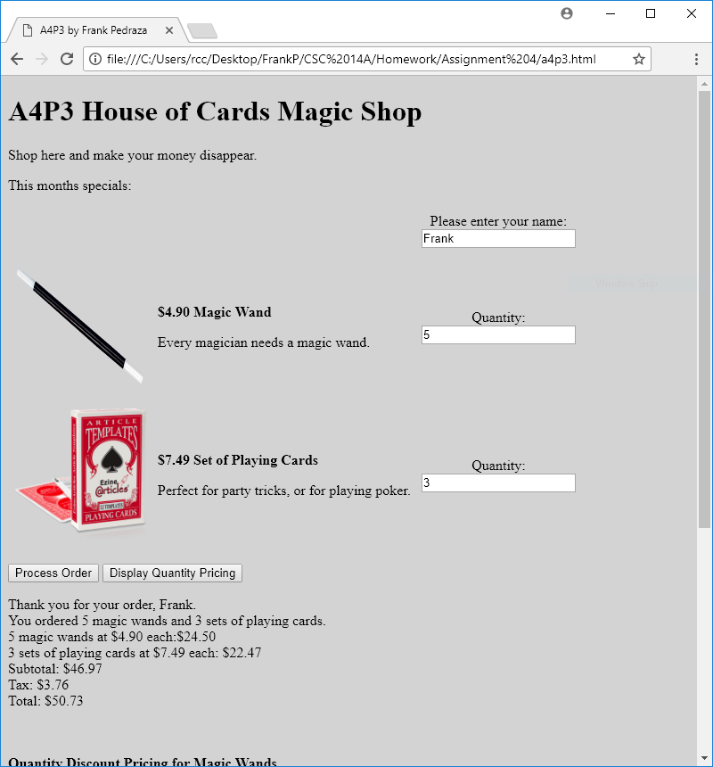

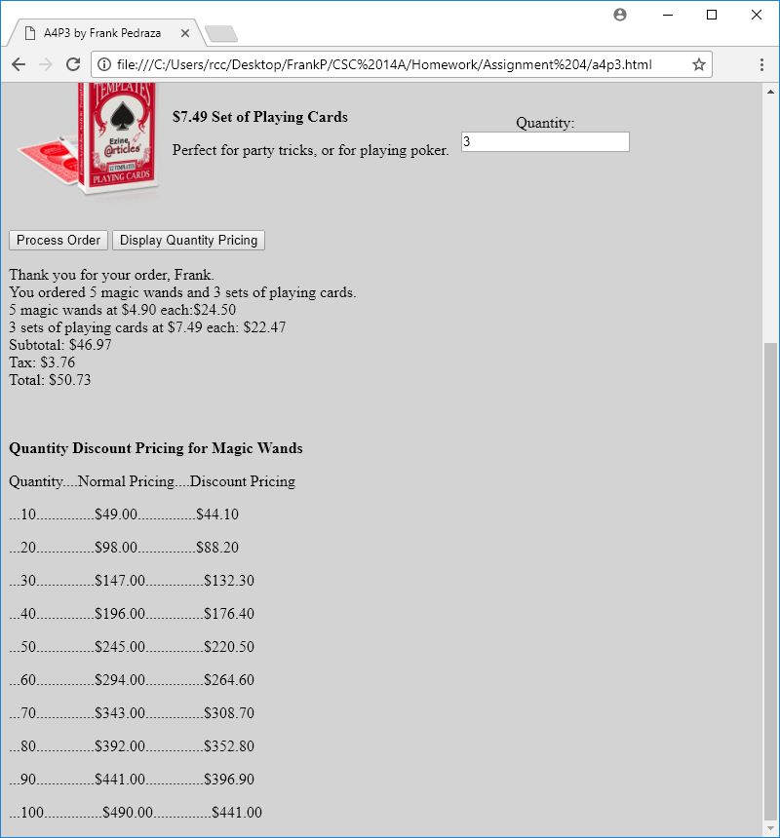

[Paste your part 3 code below your screen shot. Make sure that ALL code is visible between this page's margins]

<!DOCTYPE html>

<html lang="en">

<head>

<meta charset="utf-8">

<title>A4P3 by Frank Pedraza</title>

<script>

var wandPrice=4.90;

var cardsPrice=7.49;

function processOrder(){

var strTab='&nbsp;&nbsp;&nbsp;&nbsp;';

var objName=document.getElementById('txtName');

var strName=objName.value;

var numWands=document.getElementById('txtQ1').value;

if(numWands==""){

numWands=0;

}

var numCards=document.getElementById('txtQ2').value;

if(numCards==""){

numCards=0;

}

var wandTotal=numWands*wandPrice;

var cardsTotal=numCards*cardsPrice;

var subTotal=wandTotal+cardsTotal;

var tax=subTotal*0.08;

var total=subTotal+tax;

var strSentence='Thank you for your order, '+strName+'.<br>You ordered '+numWands+' magic wands and '+numCards+' sets of playing cards.<br>';

var strWands=numWands+' magic wands at $'+wandPrice.toFixed(2)+' each:$'+wandTotal.toFixed(2)+'<br>';

var strCards=numCards+' sets of playing cards at $'+cardsPrice.toFixed(2)+' each: $'+cardsTotal.toFixed(2)+'<br>';

var strSubTotal='Subtotal: $'+subTotal.toFixed(2)+'<br>';

var strTax='Tax: $'+tax.toFixed(2)+'<br>';

var strTotal='Total: $'+total.toFixed(2)+'<br>';

document.getElementById('receipt').innerHTML=strSentence+strWands+strCards+strSubTotal+strTax+strTotal;

}

function discountTable(){

var discountItem = "<p>Quantity Discount Pricing for Magic Wands</p>";

var header = "<p>Quantity....Normal Pricing....Discount Pricing</p>";

var rows="";

for(var i=10; i<=100; i+=10){

var normal=(wandPrice*i);

var discount=normal*0.10;

var discountPrice=normal-discount;

rows+="<p>..."+i+"...............$"+normal.toFixed(2)+"...............$"+discountPrice.toFixed(2)+"</p>";

}

document.getElementById('discountPrice').innerHTML = discountItem.bold() + header + rows;

}

</script>

<style>

body {

background-color: lightgrey;

}

table, tbody, tr, td {

border: none;

}

.col3 {

text-align: center;

}

</style>

</head>

<body>

<h1>A4P3 House of Cards Magic Shop</h1>

<p>Shop here and make your money disappear.</p>

<p>This months specials:</p>

<form>

<table border="1" cellspacing="0" cellpadding="6" summary="Table of product images, prices & descriptions">

<tbody>

<tr>

<td>&nbsp;</td>

<td>&nbsp;</td>

<td class="col3">Please enter your name:<br><input type="text" id="txtName" name="txtName">

</td>

</tr>

<tr>

<td><img src="Images/magic_wand.png" alt="Magic Wand" height="150" width="150"></td>

<td><p style="font-weight: bold">$<script>document.write(wandPrice.toFixed(2))</script> Magic Wand</p>

<p>Every magician needs a magic wand.</p></td>

<td class="col3">Quantity:<br><input type="text" id="txtQ1" name="txtQ1"></td>

</tr>

<tr>

<td><img src="Images/cards.png" alt="Playing Cards" height="150" width="150"></td>

<td><p style="font-weight: bold">$<script>document.write(cardsPrice.toFixed(2))</script> Set of Playing Cards</p>

<p>Perfect for party tricks, or for playing poker.</p></td>

<td class="col3">Quantity:<br><input type="text" id="txtQ2" name="txtQ2"></td>

</tr>

</tbody>

</table>

<p>

<input type="button" value="Process Order" id="btnProcess">

<input type="button" value="Display Quantity Pricing" id="discount">

</p>

</form>

<div id="receipt">&nbsp;</div>

<br><br>

<div id="discountPrice">&nbsp;</div>

<script>

document.getElementById('btnProcess').addEventListener("click", processOrder);

document.getElementById('discount').addEventListener("click", discountTable);

</script>

</body>

</html>

**Part 4: Display Table …**Start with A4P3, then modify code to calculate quantity discounts on the receipt and also display the discount pricing list with table formatting

[Paste your part 4 Screenshot(s) below. Make sure all of your page displays. Use 2 screenshots as needed.]

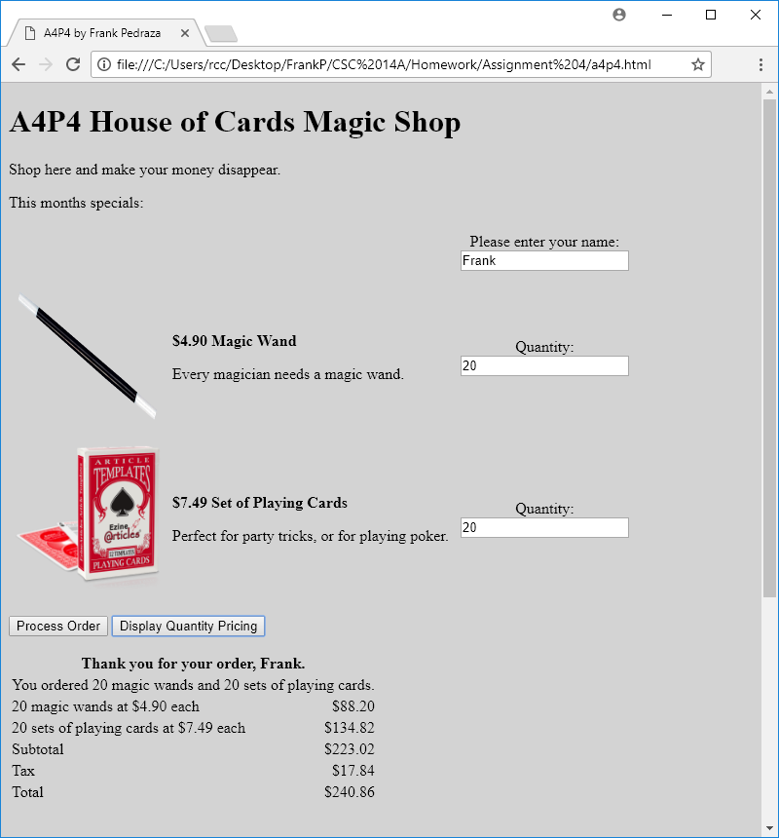

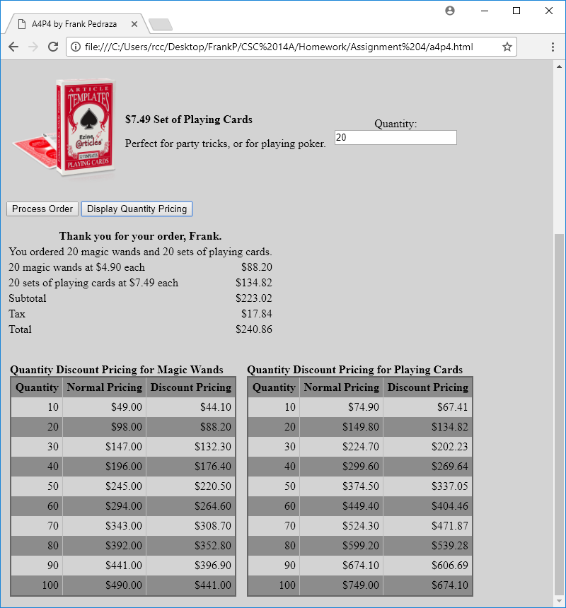

[Paste your part 4 code below your screen shot. Make sure that ALL code is visible between this page's margins]

<!DOCTYPE html>

<html lang="en">

<head>

<meta charset="utf-8">

<title>A4P4 by Frank Pedraza</title>

<script>

var wandPrice=4.90;

var cardsPrice=7.49;

function processOrder(){

var objName=document.getElementById('txtName');

var strName=objName.value;

var numWands=document.getElementById('txtQ1').value;

if(numWands==""){

numWands=0;

}

var numCards=document.getElementById('txtQ2').value;

if(numCards==""){

numCards=0;

}

var wandTotal=numWands*wandPrice;

if(numWands>=10){

var normal=(wandPrice*numWands);

var discount=normal*0.10;

var discountPrice=normal-discount;

wandTotal=discountPrice;

}

var cardsTotal=numCards*cardsPrice;

if(cardsTotal>=10){

var normal=(cardsPrice*numCards);

var discount=normal*0.10;

var discountPrice=normal-discount;

cardsTotal=discountPrice;

}

var subTotal=wandTotal+cardsTotal;

var tax=subTotal*0.08;

var total=subTotal+tax;

var strSentence='<table><tr><th colspan="2">Thank you for your order, '+strName+'.</th></tr><tr><td colspan="2">You ordered '+numWands+' magic wands and '+numCards+' sets of playing cards.</td></tr>';

var strWands='<tr><td>'+numWands+' magic wands at $'+wandPrice.toFixed(2)+' each</td><td align="right">$'+wandTotal.toFixed(2)+'</td></tr>';

var strCards='<tr><td>'+numCards+' sets of playing cards at $'+cardsPrice.toFixed(2)+' each</td><td align="right">$'+cardsTotal.toFixed(2)+'</td></tr>';

var strSubTotal='<tr><td>Subtotal</td><td align="right">$'+subTotal.toFixed(2)+'</td></tr>';

var strTax='<tr><td>Tax</td><td align="right">$'+tax.toFixed(2)+'</td></tr>';

var strTotal='<tr><td>Total</td><td align="right">$'+total.toFixed(2)+'</td></tr></table>';

document.getElementById('receipt').innerHTML=strSentence+strWands+strCards+strSubTotal+strTax+strTotal;

}

function discountWandsTable(){

var beginTable = 'Quantity Discount Pricing for Magic Wands';

var tableHeader = '<table id="pricingTable"><tr><th>Quantity</th><th>Normal Pricing</th><th>Discount Pricing</th></tr>';

var tableRows='';

for(var i=10; i<=100; i+=10){

var normal=(wandPrice*i);

var discount=normal*0.10;

var discountPrice=normal-discount;

tableRows += '<tr><td>'+i+'</td><td>$'+normal.toFixed(2)+'</td><td>$'+discountPrice.toFixed(2)+'</td></tr>';

}

var tableEnd = '</table>';

document.getElementById('discountWandsPrice').innerHTML = beginTable.bold() + tableHeader + tableRows + tableEnd;

}

function discountCardsTable(){

var beginTable = 'Quantity Discount Pricing for Playing Cards';

var tableHeader = '<table id="pricingTable"><tr><th>Quantity</th><th>Normal Pricing</th><th>Discount Pricing</th></tr>';

var tableRows='';

for(var i=10; i<=100; i+=10){

var normal=(cardsPrice*i);

var discount=normal*0.10;

var discountPrice=normal-discount;

tableRows += '<tr><td>'+i+'</td><td>$'+normal.toFixed(2)+'</td><td>$'+discountPrice.toFixed(2)+'</td></tr>';

}

var tableEnd = '</table>';

document.getElementById('discountCardsPrice').innerHTML = beginTable.bold() + tableHeader + tableRows + tableEnd;

}

</script>

<style>

body {

background-color: lightgrey;

}

table, tbody, tr, td {

border: none;

}

.col3 {

text-align: center;

}

#pricingTable {

border: 2px #666 solid;

border-collapse: collapse;

}

#pricingTable th {

font-weight: bold;

text-align: right;

padding: 5px;

border-right: 1px #BBB solid;

}

#pricingTable td {

text-align: right;

padding: 5px;

border-right: 1px #BBB solid;

}

#pricingTable tr:nth-child(odd){

background: #8c8c8c;

}

#container div{

float: left;

margin: 0px 10px 15px 5px;

}

#container div div{

float: right;

margin: 0px 10px 15px 5px;

}

</style>

</head>

<body>

<h1>A4P4 House of Cards Magic Shop</h1>

<p>Shop here and make your money disappear.</p>

<p>This months specials:</p>

<form>

<table border="1" cellspacing="0" cellpadding="6" summary="Table of product images, prices & descriptions">

<tbody>

<tr>

<td>&nbsp;</td>

<td>&nbsp;</td>

<td class="col3">Please enter your name:<br><input type="text" id="txtName" name="txtName">

</td>

</tr>

<tr>

<td><img src="Images/magic_wand.png" alt="Magic Wand" height="150" width="150"></td>

<td><p style="font-weight: bold">$<script>document.write(wandPrice.toFixed(2))</script> Magic Wand</p>

<p>Every magician needs a magic wand.</p></td>

<td class="col3">Quantity:<br><input type="text" id="txtQ1" name="txtQ1"></td>

</tr>

<tr>

<td><img src="Images/cards.png" alt="Playing Cards" height="150" width="150"></td>

<td><p style="font-weight: bold">$<script>document.write(cardsPrice.toFixed(2))</script> Set of Playing Cards</p>

<p>Perfect for party tricks, or for playing poker.</p></td>

<td class="col3">Quantity:<br><input type="text" id="txtQ2" name="txtQ2"></td>

</tr>

</tbody>

</table>

<p>

<input type="button" value="Process Order" id="btnProcess">

<input type="button" value="Display Quantity Pricing" id="discount">

</p>

</form>

<div id="receipt">&nbsp;</div>

<br><br>

<div id="container">

<div id="discountWandsPrice">&nbsp;</div>

<div id="discountCardsPrice">&nbsp;</div>

</div>

<script>

document.getElementById('btnProcess').addEventListener("click", processOrder);

document.getElementById('discount').addEventListener("click", discountWandsTable);

document.getElementById('discount').addEventListener("click", discountCardsTable);

</script>

</body>

</html>